**VIETNAM NATIONAL UNIVERSITY- HO CHI MINH CITY**

**INTERNATIONAL UNIVERSITY**

**DEPARTMENT OF MATHEMATICS**



**PROJECT REPORT**

**FINANCIAL ECONOMETRICS**

**LECTURER: DR. NGUYEN PHUONG ANH**

**TOPIC: TIME SERIES ANALYSIS FOR STOCK PRICE FORECASTING**

**GROUP MEMBER:**

|  |  |
| --- | --- |
| **Trần Quân** | **MAMAIU19037** |
| **Trần Hoàng Gia Ân** | **MAMAIU17037** |
| **Phan Thanh Mỹ** | **MAMAIU20076** |
| **Võ Thị Khánh Linh** | **MAMAIU20074** |

Table content:

Assigned task of each member 2

Objective of the project 2

Research Question 2

Data description, Data source 3

Methodology: describe the econometrics tools 3

Results and interpretations 4

Conclusion 5

References 6

# Assigned task of each member

Because we have each others on almost every tasks, so that we do not have assigned any specific tasks for each member. Therefore, we will mark this part into the percentage of contribution base on each’s performance.

|  |  |
| --- | --- |
| Trần Quân | 22% |
| Trần Hoàng Gia Ân | 26% |
| Phan Thanh Mỹ | 26% |
| Võ Thị Khánh Linh | 26% |

# Objectives of the project

Building a solid model that can reliably forecast future stock prices based on historical data is the main goal of the Time Series Analysis for Stock Price Forecasting project. To find patterns, trends, and seasonality in the time series data, sophisticated analytical approaches must be used. By offering trustworthy projections to direct traders' and investors' investment plans, the ultimate objective is to improve the decision-making processes of these parties.

# Research Question

"Can time series models effectively predict stock prices for selected company in the financial market?"

The purpose of the study topic is to find out how well time series models work to forecast stock prices for a particular financial market organization. By examining past stock price data, the study seeks to determine how accurate and reliable these predictive models are, as well as how well they can identify underlying patterns and trends. The results will provide insightful information about the usefulness of time series analysis for investors and financial professionals, which could help them make better decisions in the volatile world of stock investment.

# Data description, Data source

* Data Acquisition: We secured Marathon Digital Holding Inc. historical stock prices for a comprehensive analysis.
* Data Quality Control: We rigorously cleaned and validated the data for accuracy and reliability.
* Focused Analysis Period: We focused on the period from January 1, 2021, to June 30, 2023, and predicted the outcome 30 days ahead for targeted analysis.
* Data Visualization: We created visual representations of MARA's daily price movements for clear understanding.

# Methodology: describe the econometrics tools

1. Data Preparation: Collect and clean the data. Ensure that the data is stationary, meaning that it has a constant mean and variance over time. If the data is not stationary, you will need to transform it to make it stationary.
2. Model Selection:

* Identify AR and MA orders (p and q): Analyze the autocorrelation and partial autocorrelation plots to determine the appropriate orders of the AR and MA components.
* Seasonality: If the data exhibits seasonality (e.g., daily or weekly patterns), incorporate it by setting the seasonal differencing (d) parameter.

This can be done using statistical tests such as the Augmented Dickey-Fuller (ADF) test and the Akaike Information Criterion (AIC)

The series is already stationary, then d=0.

If selected manually, we have may ARIMA model. We must have to use AIC or BIC to choose the model which has the lowest value

However, we test automatic by using auto.arima() function. It gives ARIMA model with order p=2, d=0 and q=3

1. Model Fitting and Evaluation:

* Fit the ARIMA model to the data using the determined values of p, d, and q.
* Diagnostic Checking: Analyze the residuals (differences between predicted and actual values) for normality, independence, and constant variance. If these assumptions are violated, try transforming your data or adjusting the model

1. Forecasting:

* Predict future values: Once the model is validated, use it to forecast future price values within your desired timeframe.

1. Monitoring

* Monitor forecast accuracy: Evaluate the actual vs predicted values over time to see how well the model performs.
* Evaluate the performance of the model using statistical tests such as the Mean Absolute Error (MAE), Mean Squared Error (MSE), and Root Mean Squared Error (RMSE).

# Results and interpretations

1. For our analysis, we use continuously compounded returns, i.e., logarithmic returns, instead of simple returns, as is common in academic finance research.
2. The series is already stationary, then d=0.

If selected manually, we have many ARIMA models. We must have to use AIC or BIC to choose the model which has the lowest value

However, we test automatic by using auto.arima() function. It gives ARIMA model with order p=2, d=0 and q=3

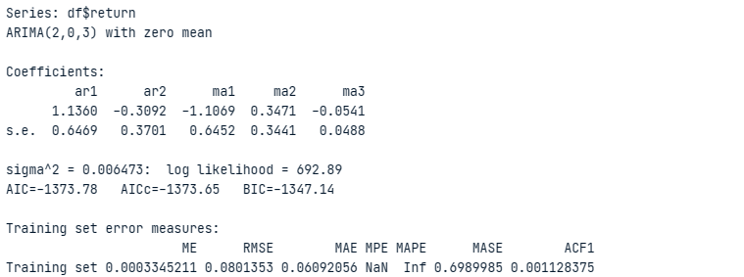

1. Check residuals by using Ljung - Box test and then we have some

* Chi-squared statistic (16.817): This measures the overall difference between the observed and expected distributions of the residuals. A higher value indicates a larger discrepancy.
* Degrees of freedom (20): This represents the number of independent comparisons made in the test.
* p-value (0.6648): This is the probability of observing a Chi-squared statistic as extreme as 16.817 or greater, assuming the null hypothesis of no difference is true. A p-value less than 0.05 typically indicates rejection of the null hypothesis and suggests a significant difference.

Therefore, based on the provided information, you can conclude that the model's residuals are not concerning and the model provides a good fit to the data.

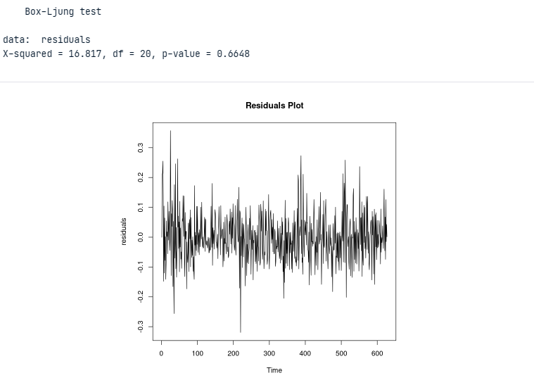

1. Forecast the next 30 days
2. Evaluate the performance of the ARIMA (2,0,3) model using statistical tests

* MSE (0.01671588): This indicates a relatively low average squared difference between forecasted and actual values, suggesting good overall accuracy.
* MAE (0.09846362): This suggests an average absolute error of around 0.1 units, which provides a more practical understanding of the typical error magnitude.
* ME (0.04563536): The positive value indicates a slight tendency to overestimate, but its magnitude is relatively small, suggesting no significant bias.

# Conclusion

The calculated Mean Squared Error (MSE), which stands at 0.01671588, indicates a favorable overall prediction accuracy due to the very small average squared difference between the actual and forecasted stock values. A useful indicator of the average size of prediction errors is the Mean Absolute mistake (MAE) value of 0.09846362, which indicates an average absolute forecasting mistake of about 0.1 units. With a positive value of 0.04563536, the Mean Error (ME) indicates a modest bias toward overestimation. Nevertheless, the bias's magnitude is quite small, indicating the absence of severe systematic forecasting errors. As a result, the thorough analysis of these indicators confirms the conclusion that the time series models used are useful in accurately predicting stock prices for the chosen financial sector organization.

# References

Box, G. E. P., Jenkins, G. M., & Reinsel, G. C. (1994). Time Series Analysis: Forecasting and Control. Wiley.

Hyndman, R. J., & Athanasopoulos, G. (2018). Forecasting: Principles and Practice. OTexts.

Hamilton, J. D. (1994). Time Series Analysis. Princeton University Press.

Brockwell, P. J., & Davis, R. A. (2006). Introduction to Time Series and Forecasting. Springer.

Cryer, J. D., & Chan, K.-S. (2008). Time Series Analysis: With Applications in R. Springer.

Yahoo Finance. (n.d.). Marathon Digital Holdings Inc. (MARA) - Historical Data. Retrieved January, 10, 2023, from <https://finance.yahoo.com/quote/MARA/history?period1=1688169600&period2=1691971200&interval=1d&filter=history&frequency=1d&includeAdjustedClose=true>.